Upper Tier Major Hazard Facilities: Safety Case Summary for Liquigas Ltd www.liquigas.co.nz

[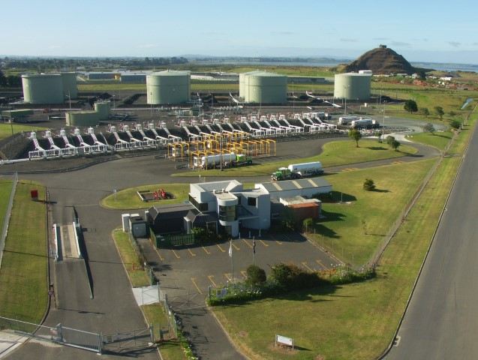](http://sid/Pictures/Auckland%20Depot/Aerial%20View%20of%20Auckland.jpg)

## **Liquigas Safety Cases:**

## – Auckland

## – New Plymouth

## – Christchurch

## – Dunedin

**Storing LPG Safely**

LPG (Liquefied Petroleum Gas) is the generic name for mixtures of propane and butane, usually around 60% propane and 40% butane. When lightly compressed the gases change to a liquid. LPG is heavier than air, colourless and odourless – although a chemical is added to give it an unpleasant smell to ensure that even a small leak can be detected.

To safely manage the bulk storage and distribution of LPG, our people are highly trained and work in an environment that puts safety first.

Our sites have been designed and constructed to the highest standards of safety, and we were the first company in the world to fully mound our steel storage tanks by encasing them in sand. Mounding our storage tanks provides a significant barrier against fire and external impacts and allows the tanks sufficient movement in the event of an earthquake.

We have many controls in place to ensure that our people and the communities we operate in are always safe. These controls are reviewed regularly to ensure we retain the highest levels of safety technology.

**Health and Safety at Work (Major Hazard Facilities) Regulations 2016**

Due to the quantities of LPG that we store at our sites, Liquigas is known as an upper tier Major Hazard Facility under the Health and Safety at Work Act 2015. We have a responsibility under the MHF Regulations of the Act to prove to WorkSafe New Zealand that our safety, operating, and maintenance systems keep our risks as low as possible, and our people and communities safe.

We meet this responsibility by developing Safety Cases that are a comprehensive investigation and analysis of all aspects of risks to health and safety associated with major incidents on our sites. Our major risk is from an uncontrolled release of LPG because it could catch fire if it was to reach an ignition source. Potential uncontrolled releases may come from piping, during shipping operations or during road tanker operations. These systems contain significantly less LPG than our storage tanks.

Safety Cases include three main sections:

1. **Safety Management System (SMS)** that documents all the policies and procedures that we use to safely operate our depots.
2. **Safety Assessments** that are used to identify and control the risk of a major incident.
3. **Emergency Response Planning** that ensures we are trained to react quickly and safely to an emergency if one was to ever happen.

**Our Safety Cases**

Our Dunedin Safety Case was one of the very first to be accepted by WorkSafe NZ under the MHF Regulations. It was prepared in collaboration with workers, safety specialists, emergency services, contractors, and WorkSafe, and accepted by WorkSafe in May 2019. Our Christchurch Safety Case was accepted in August 2019, our Auckland Safety Case in November 2019, and our New Plymouth Safety Case in February 2020.

* **Safety Management System (SMS)**

The contents of our SMS flow from our Mission Statement. Our policies and procedures cover the subjects of:

1. Policy, Planning & Objectives.
2. Engaging with Workers.
3. Organisation & Personnel.
4. Risk Management.
5. Operational Controls.
6. Human Factors.
7. Management of Change.
8. Incident Management.
9. Performance Monitoring.
10. Occupational Health and Wellbeing.
11. Environment.
12. Emergency Response.
13. Audit & Review.
14. Records Management.

* **Safety Assessments**

We conducted multiple studies to ensure that we fully understood our risks:

* Risk and Assurance Statements
* Quantitative Risk Assessments
* Process Safety Audits
* Layers of Protection Analysis
* Human Factors Review of Safety Critical Procedures
* Control Building Vulnerability Assessments

We engaged with workers, safety specialists, emergency services, and contractors to identify the major Incident risks on our depots. These are:

MI-01: Loss of containment during ship operations

MI-02: Loss of containment from underground piping

MI-03: Loss of containment from pressure vessel or piping

MI-04: Loss of containment during road tanker operations

MI-05: Loss of containment of mercaptan

We ensure that our controls for those risks mean that we can operate safely. We understand the objective of each of our controls, we ensure that the controls are certified and regularly reviewed, and we monitor their performance.

* **Emergency Planning**

We regularly practice our emergency response in collaboration with workers, the emergency services, and the local authorities. We have controls to ensure that we will detect any issues very quickly, and others that help us to safely manage an emergency. These include comprehensive gas detection, fire detection, automatic shutdown systems, and water deluge systems.

**In the rare event of an uncontrolled release, a fire siren will sound, the plant will be shut down, water sprays will activate throughout the depot and the Fire Service automatically alerted to provide support. These actions will occur even if it is a false alarm.**

**We will call our immediate neighbours to notify them of an uncontrolled LPG release, and other neighbours may be contacted by emergency services. Please shelter in place and do not approach the depot with ignition sources such as cell phones. Although LPG is not toxic and readily evaporates, in cold conditions with very low wind speeds, a visible vapour cloud may travel a distance on our depot at wind speed. Self-evacuate away from the direction of a visible vapour cloud.**

**Liquigas Summary and Further Information**

